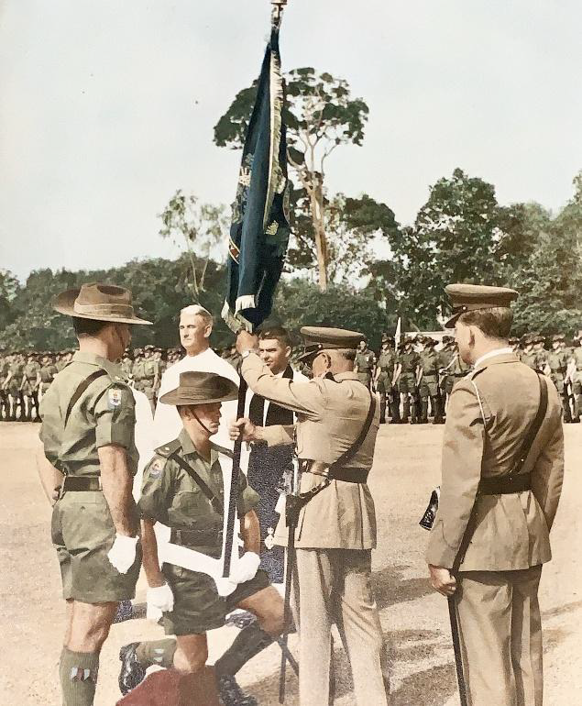
LT Geoff Everett, accompanied by SGT Dick Kennedy, receives the 8 RAR Regimental Colour, presented by MAJGEN Sir Reginald Pollard. CAPT Rick Haines looks on as ADC.

