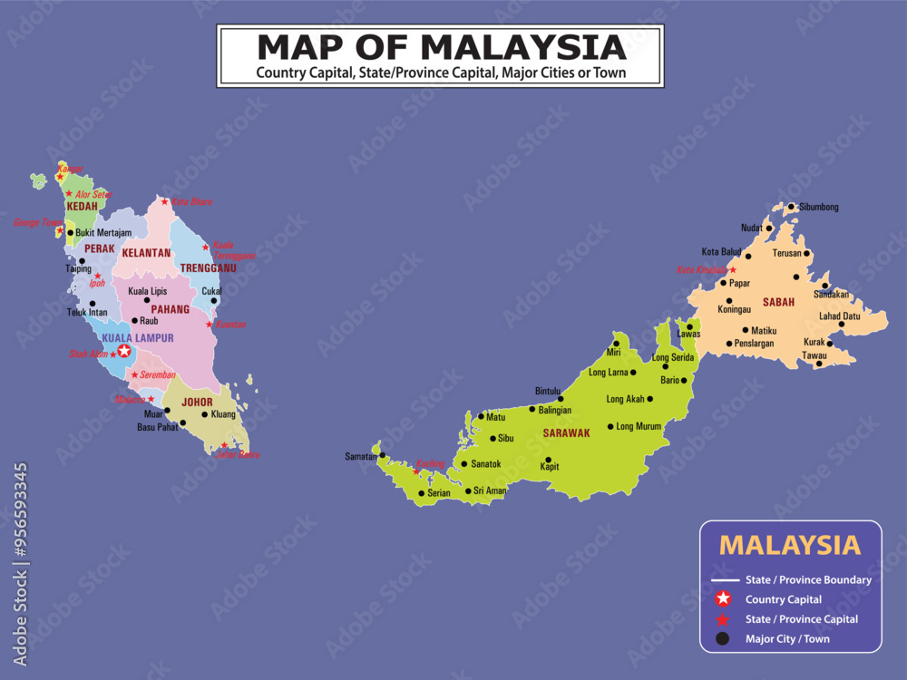

Malaysia.
In 1967 8RAR replaced 4RAR in Malaysia, being deployed with families to Terendak camp in Southern Malaysia for a two-year tour of duty. The Battalion was part of the 28th Commonwealth Brigade, which itself was part of the British Commonwealth Far East Strategic Reserve. (BCFESR) Their main role was training, and they provided a level of security for the region by their presence.
By the time 8RAR arrived in Malaysia, the future of the 28th Commonwealth Brigade and the BCFESR were under review. The British decided that half of the deployed force would be withdrawn by 1971 and the rest by 1973-76. A review by Australia determined that the contribution to the Strategic Reserve would be maintained but the next Australian battalion would relocate to Singapore.
Having already been warned for service in Vietnam the Battalion trained hard for their upcoming challenge while in Malaysia. The Battalion returned home to Enoggera in April 1969 and prepared for war.
Malaysia
Recollections from Simon Kleinig

At Reinforcement Holding Unit (RHU) at Ingleburn we were told we would be posted within days to the 8th Battalion, Royal Australian Regiment. The 8th Battalion colours were grey and for that reason the battalion was known as ‘The Grey Eight’. When I joined the Eighth Battalion (8 RAR) in Setpember, 1968, it was based at Terendak Garrison in Malaysia. Terendak was situated on the coast, 13 miles (21 km) from the town of Malacca, and roughly halfway down the Malay peninsula facing the straits of Malacca and the large island of Sumatra.

We flew out of Sydney in a Boeing 707, which had succeeded the old Super Constellations and Douglas DC-7s, shortly to be overtaken themselves by the new Boeing 747s, the so-called Jumbo jets, the aircraft which would transform commercial aviation and herald in a new era of fast and affordable international air travel.

I was excited as our aircraft touched down in the tropical heat of Singapore. This was the first time I had left Australia, and I relished the prospect of seeing a different country, culture and people, even if it was through the eyes of a serving infantryman. Singapore Airport was a busy terminal, but still light years away from the exciting international crossroads it would become decades later. We were taken by trucks to nearby Nee Soon Garrison, where we climbed into buses for the long journey north across the causeway at Johor Bahru and down the Malay Peninsula.

The close and steamy Malayan countryside was very different to the sun-drenched, extended Australian landscapes we were used to. Lush, tropical greenery swept past the bus windows, and every now and then we came upon small villages or Kampongs, where wooden huts with thatched roofs stood tall on stilts above wet paddy fields, grazing water buffalo, pigs and poultry. I wrote about it in a letter home:

‘From Singapore to Terendak the land is generally flat, with mountainous regions developing to the north. Much of the land is occupied with rubber plantations, together with pineapples and bananas. A large causeway, about half a mile long, connects Singapore with the Malay Peninsula. On the Malay side is situated Johor Bahru, quite a large town, but between here and Terendak there are no large towns to speak of’.
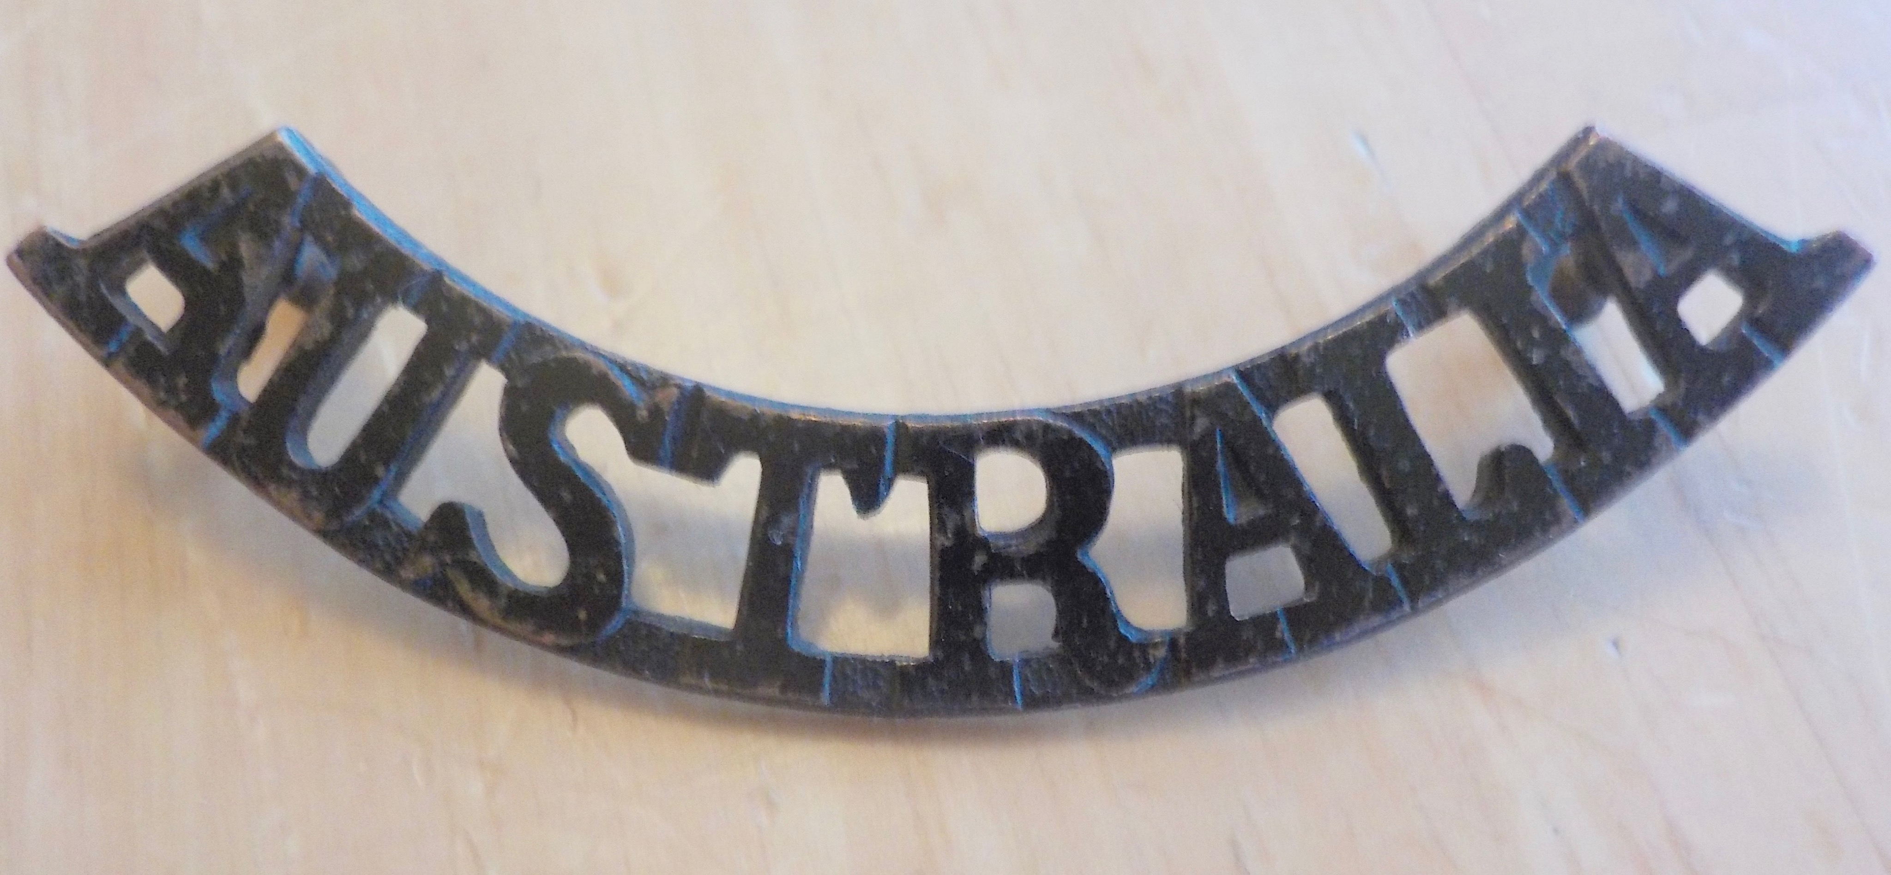

We passed through Malacca, a bustling town of shambolic traffic, trishaws, cars, water buffalo and people all competing against each other. In Malacca unwary or complacent pedestrians always came off second-best. Fourteen miles further north we turned into the entrance gates to Terendak Garrison, and a short distance further on our buses pulled up at the lines of the Eighth Battalion, Royal Australian Regiment. Our battalion formed part of the 28th Commonwealth Infantry Brigade, an international unit comprising British, Malay, Gurkha, Australian and New Zealand troops.

I was posted to 10 Platoon, 'D' (Delta) Company, and as soon as we had settled into our quarters we began an acclimatisation course. This was to help us make a quick transition to the steamy and oppressive tropical heat, as I explained in a letter home:

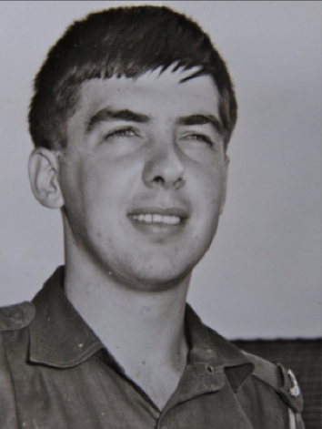
‘For the next two weeks we are doing an acclimatisation course consisting mainly of three-mile runs. I don't feel that tired after the runs but I have never perspired so much in all my life. Even after three days I find myself getting used to the climate. Each day we take one paludrine tablet to combat malaria, about half the size of a one cent coin. It’s great walking around in shorts and sleeping with just a sheet on. It rains heavily here every day for about three hours, but as soon as the rain has passed the day breaks into brilliant sunshine again. After the rain stops a noticeable difference in the atmosphere occurs—the air suddenly becomes heavy and humid, and for about an hour afterwards it takes on a strange, steamy condition. Everything here is so green—not the green we see back home, but a lush, radiant green. The sky looks dull and restless, and the thunderhead cloud formations are typically monsoonal. There are palms, hibiscus and banana trees everywhere around our lines’.

Our exercises in the bush were long, hard and tough, the Malayan jungle being amongst the worst in the world. It was perpetually hot, steamy and damp. Our greens were always wet, either through tropical downpours or from our own perspiration. Everything in the jungle was big—rainfall, plants, undergrowth, insects.

One of my early letters home describes my first impressions of the Malayan landscape:

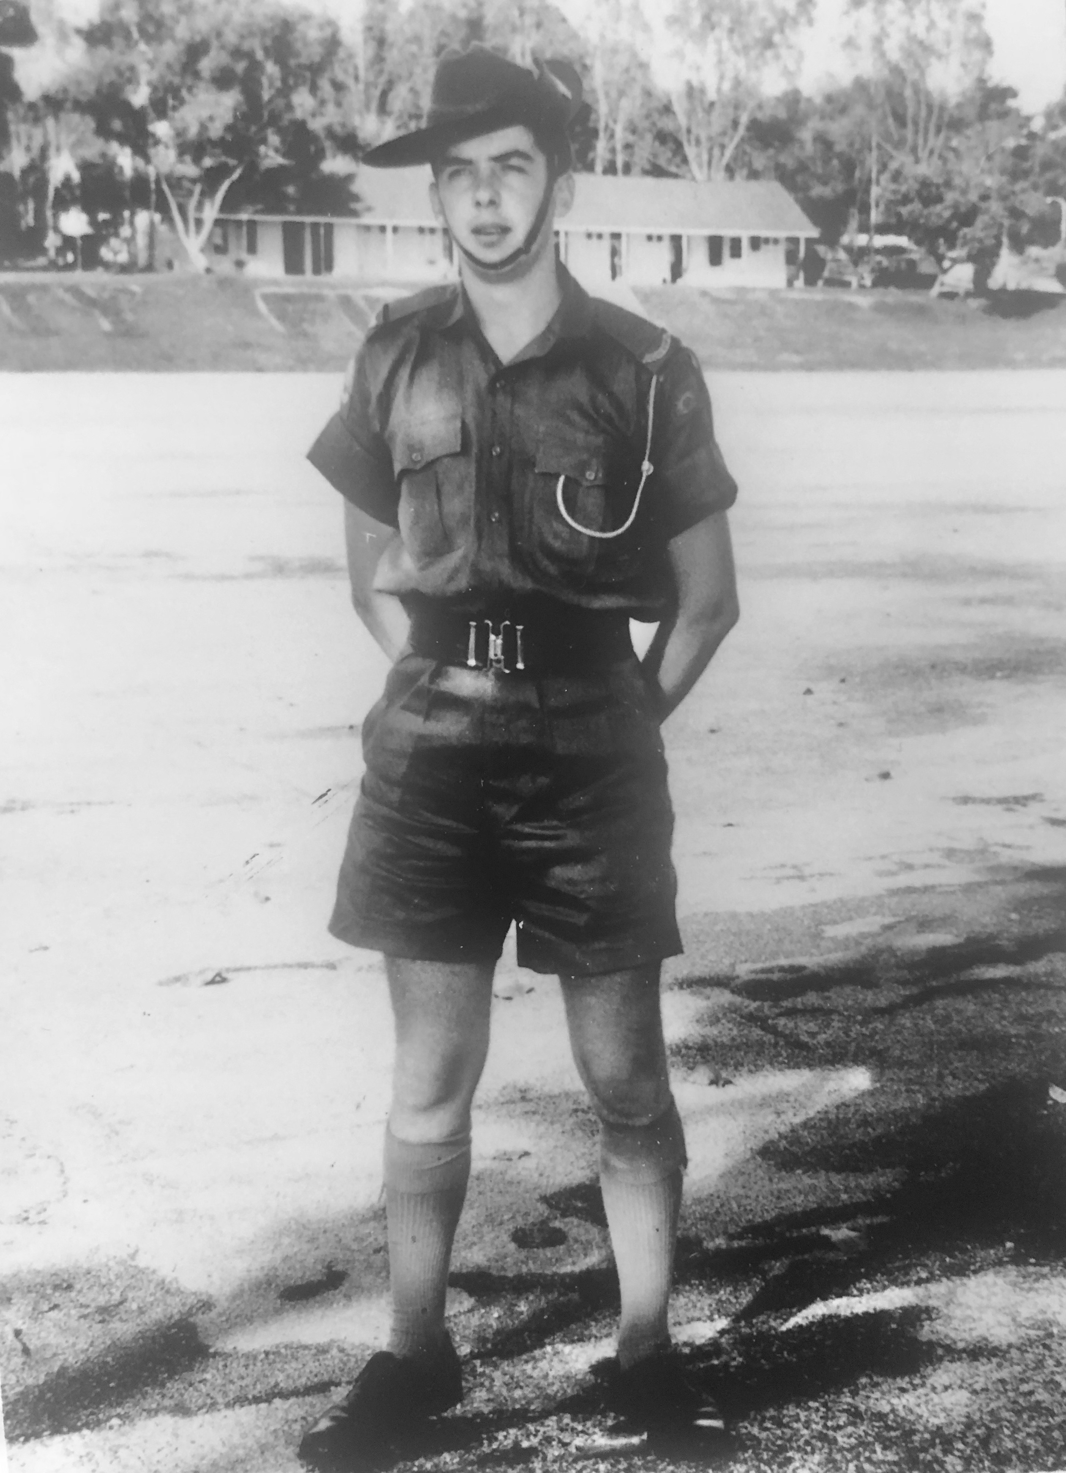
‘The surrounding countryside is interesting. About two miles from Terendak Garrison is a large rice paddy which extends for miles, finally disappearing into a series of spurs and valleys in a nearby mountain range. The road into Malacca is 13 miles long and is flanked by palms and houses of the local inhabitants made of thatched grass and elevated on stilts. Some of the houses, which in the main are uninviting, support a few acres of vegetables. Water buffalo are used as beasts of burden. The road is quite dangerous to travel and you can often come round a curve to be confronted by two or three water buffalo’.

Soon after arriving I came down with a case of ‘monsoon blisters’. This developed as an angry red rash which infected the upper groin of both legs. It was very painful and I had trouble sleeping at night when salt from perspiration seeped into the open blisters. I went to the RAP (Regimental Aid Post) and a medical orderly prescribed ‘purple paint’ to dry out the infected area, but this had limited success only.

After weeks of agony, when even the wearing of shorts caused me painful discomfort, I resorted to self-diagnosis and self-treatment. Another soldier in our dormitory suggested I try pouring iodine over the blisters, warning me that ‘you’ll climb walls for the first five minutes, but you’ll get rid of them’. And he was right — it was searingly painful for the first few minutes, but within 24 hours the monsoon blisters had dried out completely and I suffered no longer.

My former civilian occupation was not entirely overlooked, and after I while I was transferred to CHQ (Company Headquarters) to help out with clerical work, though my regular role as rifleman was never far away. Apart from training exercises in the bush,
we spent evenings on guard duty, patrolling our company lines on the edge of thick jungle with rifle and fixed bayonet.
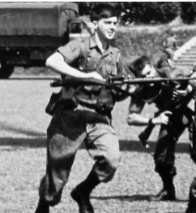
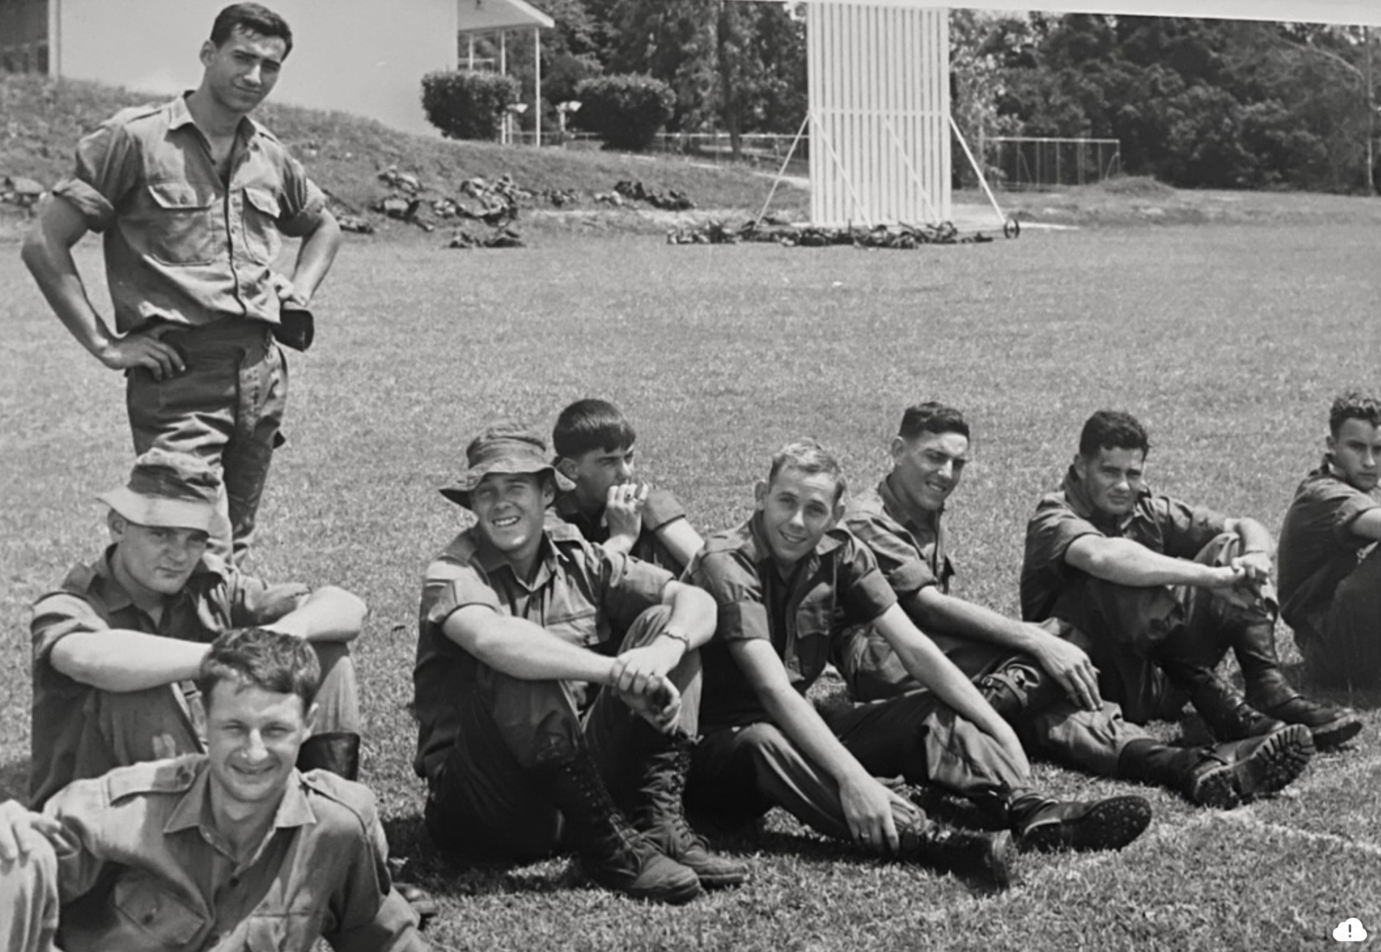
We had helicopter training using British Whirlwind Mark Ten and Wessex helicopters, where we learnt winching and de-planing techniques, and how to attach loads. De-planing was simple; the helicopter went into a hover about 15 feet above the ground and we just jumped out — with rifle, webbing and full kit, landing heavily.
Helicopter training, Terendak, September 1968

For recreation, movies were shown each evening, or we could go swimming at the local beach, where refreshments and light snacks could also be purchased at 'The Beach Club'. It was a very relaxing place to be after a hard day's soldiering and the view out across the Straits of Malacca was wonderful. The jungle grew right down to the beach, overhung by leaning coconut palms, and at last light, as the orange sun sank below the horizon, the gentle slop of waves on the beach was mesmerising.The tropical water was perfect for swimming, the only drawback being seasonal infestations of 'Man 'O War' jellyfish.

A curious army tradition I noticed was the continuing use of quaint terms from the past. For example, when we began our shift we ‘mounted guard’ and at the end of it we ‘dismounted guard’. For repairs to our rifles and other equipment we went to the ‘armourer’. We also used ‘digger’ in the army, a name which first came into use during the Gallipoli campaign.

Guard duty was tedious and tiring. It took the form of 'two hours on, two hours off' throughout the night, so that when the shift was finished next morning — so were we. Tired and sweaty from sleeping in our greens, suffering birdcage mouth from too many cigarettes and cups of coffee, we still had a full day of soldiering ahead of us. The Guard House had a room fitted with iron bunk beds in which we slept fitfully for two hours between shifts. It also contained holding cells for soldiers brought in by the MPs (Military Police) for offences such as drunkenness or for 'conduct to the prejudice of good order and military discipline’.

One night I was out patrolling the perimeter of our 8 RAR lines with rifle and fixed bayonet when I came across another soldier on guard duty. He was not someone I particularly liked. We had gone through recruit and corps training together and I knew him as a braggart and a loudmouth. He wanted to chat, and guard duty being boring beyond belief, I listened. He was resting on his rifle, butt on the ground, when suddenly he lost his grip and let the rifle fall. It fell heavily through an arc of 180 degrees, the bayonet slicing through my greens like paper, leaving a neat, almost surgical, four-inch gash in my inner thigh. Another couple of inches and my four children would never have been born.

The historic, coastal town of Malacca, close to Terendak Garrison, became very familiar to me over the next six months. But my first impressions of the town were not good, nor would they improve with time:

‘Malacca consists of thin, narrow streets with unattractive buildings built right up against one another and crowding into streets filled with chaotic traffic. Throughout the town there is an almost unbearable stench, the streets are littered with rubbish and would be lucky to get a sweep once a week, if at all. At night, shopkeepers just sleep outside their shops on sheets of cardboard, while rats, some almost as big as cats, run everywhere, even over the sleeping bodies. The thing I notice most over here is the poverty—something you just don’t see in Australia.’

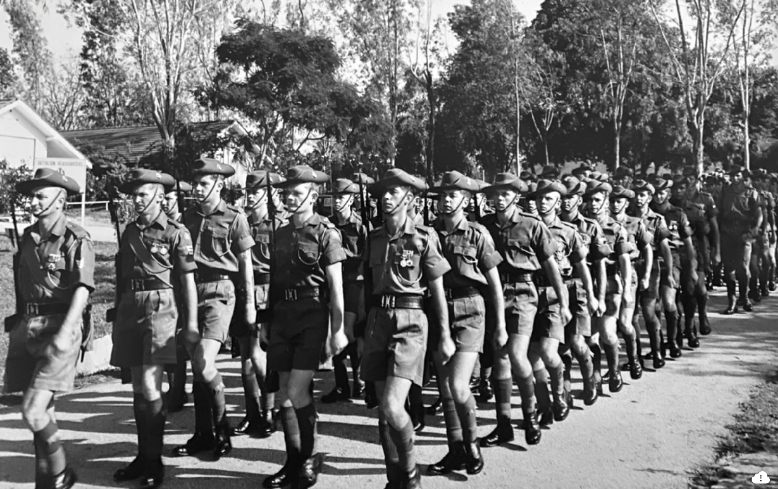
Malacca did interest me for its colonial history. It had been settled by the Portuguese in 1511 and later by the Dutch and British, the latter through the British East India Company. I was fascinated by the visible relics of these days; the remains of the old gateway and fortress, Porta de Santiago. Another site I enjoyed visiting was old St Paul’s church, built high up on a hill overlooking the town, and dating from 1521, its story told in the weathered tombstones of its churchyard.

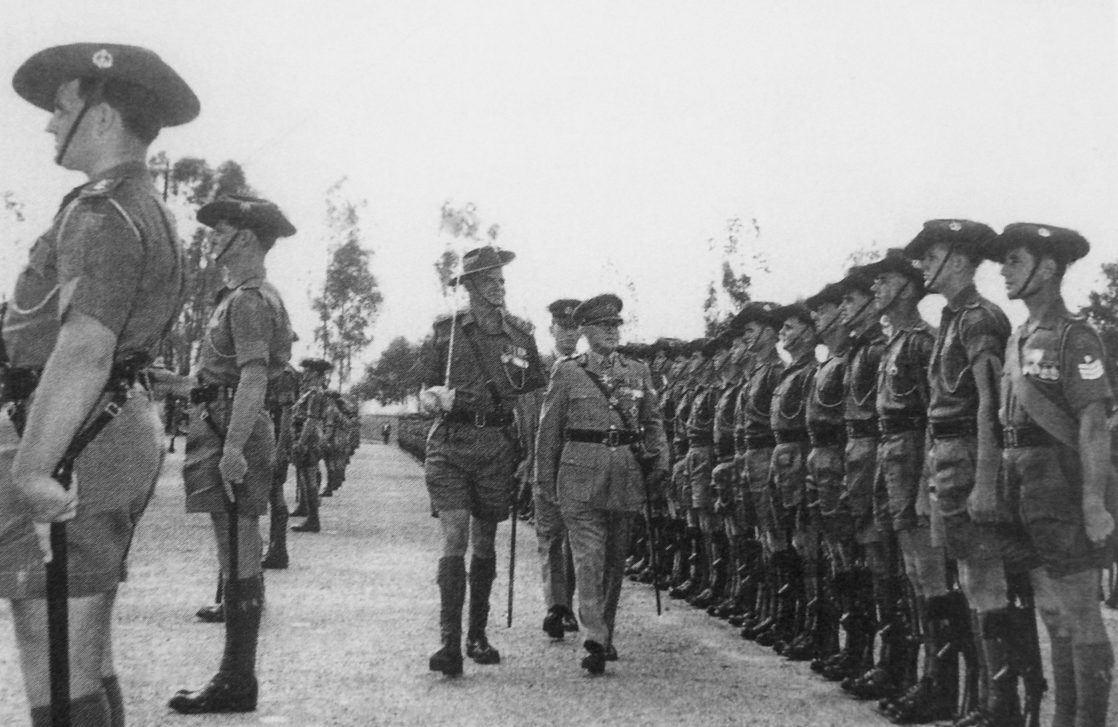

8 RAR Colours Parade, Terendak, 25 September 1968

Our 8 RAR lines were made up of parallel rows of buildings of whitewashed masonry, attractively designed and functional, fitted with large, airy shuttered windows for ventilation, with roofs of grey cement tiles.The lush tropical jungle right outside our door formed a dense green wall and was alive with monkeys.

These frequent and often unwanted visitors enjoyed swinging from the roof beams of our huts, successfully dodging hurled abuse, books, and anything else close at hand. The huts were partitioned into two large dormitories which accommodated eight iron beds, each complimented with an upright ‘locker personnel’.

The rule of lights out by 10pm was mostly observed, though not rigidly enforced. By midnight the huts would fall silent, apart from the drone and whistle of the occasional snorer. Merry-making soldiers returning from a big night out in Malacca often got up to no good. Two soldiers in particular hit upon a practical joke which lasted for weeks.

Unhooking one of the fire buckets from the outside wall, these pranksters would fill the bucket at a nearby tap, creep into the room and toss the contents over a sleeping victim. This person was usually someone they didn't particularly like. Rushing out the door, they quickly melted into the night, doubling-over in fits of laughter. The victim, suddenly and rudely awakened from deep slumber would be incensed, issuing forth a torrent of abuse and profanity.

Apart from being drenched from head to foot, including all his bedding, the whole hut would also be awakened and disturbed. It was a practice the OC (Officer Commanding) Delta company soon heard about and took very seriously. If the culprits were ever found out they could expect to be in deep trouble. But they repeated the prank several times, and despite the risk of punishment, were never found out. As the saying goes: ‘you can away with anything in the army as long as you don’t get caught’.

Labour in Malaysia was cheap in 1968, and even as humble privates we got spoiled. In all my time at Terendak I don’t think I ever cleaned my boots or washed my clothes once. Each platoon had its own ‘boot boy’, and ours was a friendly, middle-aged Malay named Morrie, who cleaned our shoes and spit-polished our parade boots (number ones) to a deep, lustrous shine. All our laundry (dobie) was done for us, and our greens, shorts and shirts came back so stiffly starched they almost stood up on their own. All this cost us just a few dollars each week. It was a hangover from British Colonial days, and it was looked upon favourably and even endorsed by high command as it provided much-needed local employment.

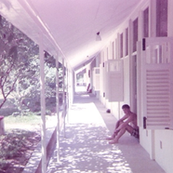
Beyond the entrance gates to Terendak a road extended for 13 miles to Malacca, known to soldiers from the Garrison as ‘The Strip’, and upon whose patronage it depended for its survival. The Strip offered a broad selection of shops selling everything from clothing to food items, from furniture to souvenirs. My own shopping tastes proved eclectic: I bought several books, a cheap, f–hole guitar with a body of garish sunburst, the newly-released Beatles ‘White Album’, Jimi Hendrix's 'Electric Ladyland', a bronze Chinese dagger in a red scabbard and a Nepalese Kukri, a large, broad-bladed Gurkha knife with an inwardly-curved edge, which, once unsheathed—so the story went—could only be returned to its scabbard once blood had been drawn.

Delta Company lines,
Terendak Garrison,
December 1968

I also got several shirts and three pairs of tailor-made trousers at ridiculously low prices. As well as retail shops, there was an interesting string of sleazy wine bars known as ‘The Strip’ aimed squarely at spendthrift and pleasure-seeking Australians: ‘The Sydney Bar’, The Victoria Bar’, 'The Adelaide Bar' and ‘The Canberra Bar’, together with numerous brothels which, despite being strictly ‘off limits’, were regularly patronised. Generally though, I took ‘The Strip’ in small doses and preferred to spend my leisure time in Malacca, which, despite its faults, offered a more colourful and interesting experience.

Our CSM (Company Sergeant-Major) was Alex Von Kurtz, a tall, lanky German aged in his mid-forties, who had emigrated to Australia as a young man and promptly enlisted in the army. The story went that 'Von' had served compulsorily in Hitler Youth during World War Two. He was forever directing his soldiers to 'get a haircut—you look like a Beatle', as soon as our hair on the sides grew to more than a centimetre in length. Von's bark was worse than his bite. He was a strict but fair senior NCO, and overall he was respected by the men of Delta company— 'liked' would be a step too far.

Von was sceptical of the strong emphasis placed on the playing of sport at Terendak. He referred leeringly to any soldier-sportsmen in Delta Company as 'jock-strapping bastards'. When other companies spent the afternoon playing football and soccer, Von Kurtz would often fall us out to practise jungle tactics—contact-left, contact-right and ambush procedures. 'I've never yet seen a Viet Cong killed by a football', Von would argue.

Once, while on orderly room duty, I was called in unexpectedly by Von: 'Private Kleinig, get your hat and rifle'—I was to act as escort for a soldier on a charge, or ‘fizzer’. Charges were heard by the OC of Delta Company, Major David Holford, a competent officer and a fair man. It was effectively a military trial for minor offenders. The guard party was made up of the accused soldier and two escorts, myself included. We marched the charged soldier, Lawrie Rowley, into the OC's office, with CSM Von Kurtz behind us barking out commands: ‘Prisoner-and-Escort, quick march!—left, right, left, right—halt!—right face!

The OC then read out the charge:

'Whilst on War Service, 276345 Private Lawrence J. Rowley, is hereby charged with conduct to the prejudice of good order and military discipline in that he was found at 2200 hours on Sunday, 2 November 1968 in the vicinity of ‘Maylees’ , a known brothel. When approached by 376993 Corporal John P. Hastings, Royal Australian Army Provost Corps and ordered to leave, the accused replied, ‘What are you, some sort of a cunt?’

The OC then asked the accused whether he had in fact said this. 'Yes sir, I did’, Private Rowley protested vigorously, 'but I was drunk at the time'. Despite the serious formality of military procedure it was difficult to keep a straight face. The OC awarded Private Rowley seven days confined to barracks.

The purpose of the battalion's stint in Malaya was two-fold. First, the jungle conditions of Malaya made it ideal preparation and training for our forthcoming tour of Vietnam. Second, having an infantry battalion deployed in South-East Asia made good tactical sense in case support was needed urgently in Vietnam. All our training was directed towards that possibility. Apart from exercises in the bush, we had a series of training flights, moving troops in large numbers between towns, using Andover and Caribou short-take-off aircraft, together with the giant Hercules transport aircraft which could accommodate both troops and large vehicles.

In February 1969 the whole Battalion took part in one of these mobilisation exercises, code-named 'Operation Fast Move'. We were driven by trucks right down the Malay Peninsula to Singapore, and flown to Kuala Lumpur in Andover aircraft, then back into the trucks for the final journey to Terendak, via Seremban, a town which I particularly liked. Apart from anything else we were given a quick, 48-hour look at an interesting part of Malaysia and Singapore.

Shortly after 'Operation Fast Move' I took four days leave and with a friend went down to Singapore to celebrate the Chinese New Year. From Johor Bahru we took a steam train across the causeway into Singapore, my last journey on a bona fide commercial steam train before they were relegated to a mere historical curiosity. We stayed
at the Union Jack Club, a British military accommodation facility. We went shopping, sightseeing, hung out in bars, played up and throughly enjoyed ourselves.

We visited the famous Tiger Balm Gardens, the Singapore Zoo, shopped 'duty free', walked around Raffles Square and along the busy waterfront of Singapore Harbour, teeming with colourful craft of every size and description. But the most lasting impression I have of Chinese New Year is lying back in a trishaw after a long, alcohol-fuelled evening touring the bars of Singapore, and gazing up wide-eyed at a sky filled with exploding fireworks.

I visited Singapore thirty-four years later in November 2002. I found the city unrecognisable. Over the decades it had been transformed into a modern, soaring, sanitised metropolis, a magnetic destination for millions of international tourists. The new Singapore presented itself attractively on the world stage. But its old intrigue as the Crossroads of the Orient, with its irresistible charm and distinctive Chinese character, had disappeared. And Singapore was a lesser place for it.
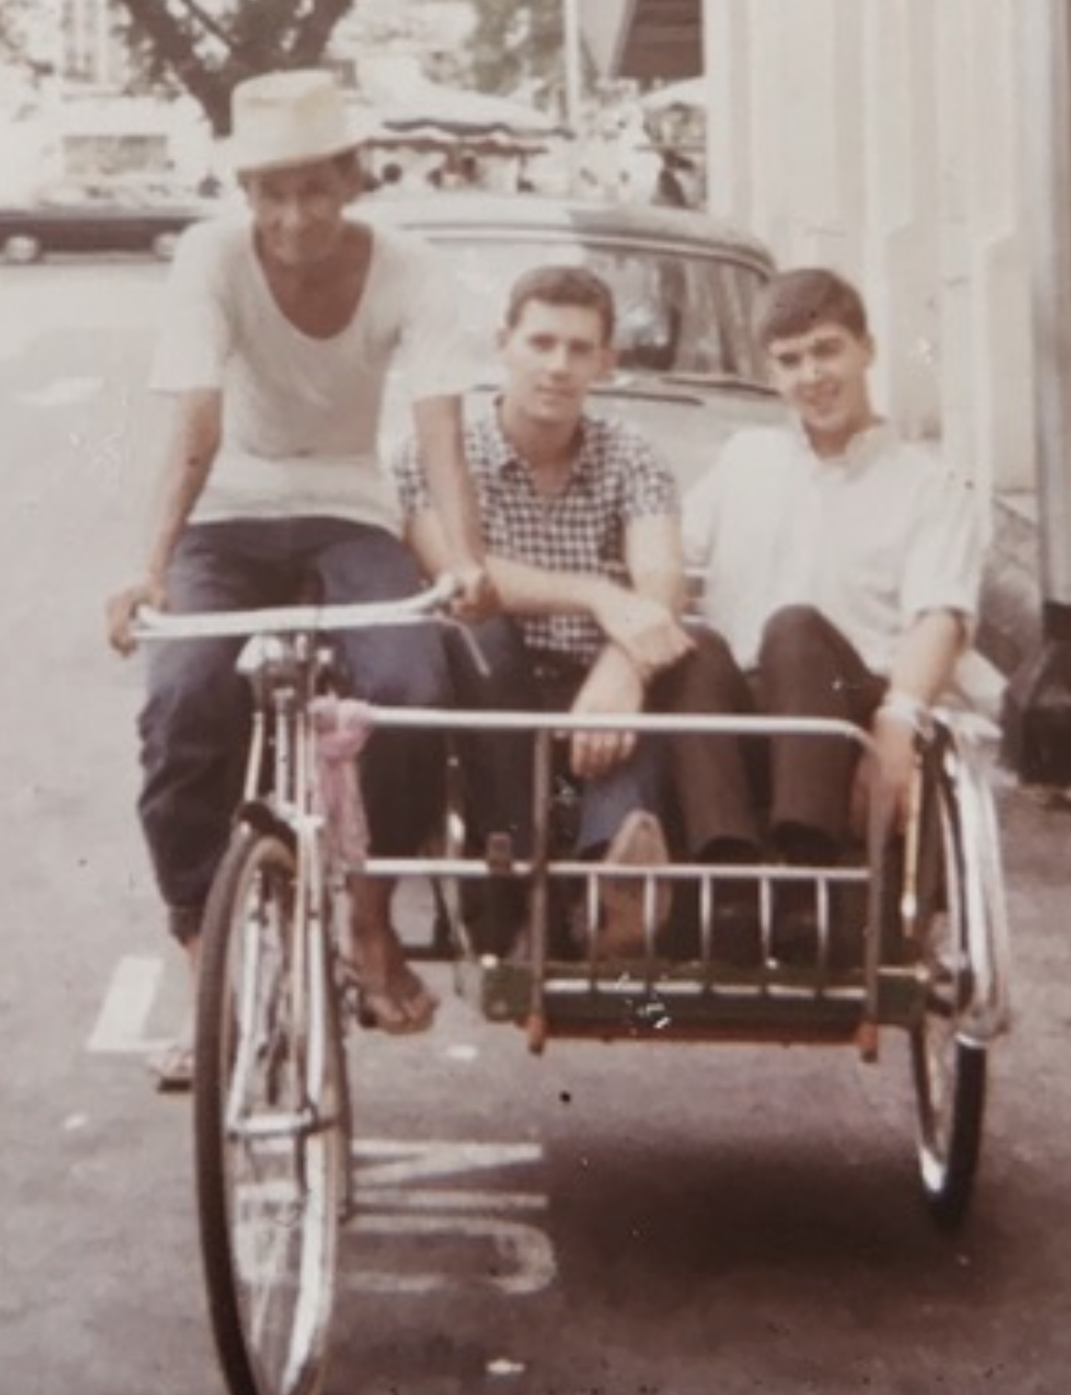

Trishaw outside
Union Jack Club,
Singapore,
February 1969

