REPUBLIC OF VIETNAM GALLANTRY CROSS WITH PALM UNIT CITATION

Under the Vietnamese system, again copied from France, when a unit was cited as a whole, a single cross was awarded to the Commanding of Officer of the unit and another single cross to the unit itself, the latter being pinned to unit colour, banner, guidon or flag. In the event that a unit was cited for the Gallantry Cross as a unit a second time the unit then became eligible to wear an item (again copied from French practice) known as a fourragere. This was an ornate lanyard in the colours of the ribbon of the Gallantry Cross.

Because the fourragere could only be awarded after a second citation at unit level and thus for a single citation there was nothing for unit members to wear to show they had served with a cited unit, at US request in 1968 the Vietnamese Government established a unit citation emblem for the Gallantry Cross. This emblem consists of a piece of Gallantry Cross ribbon set inside a gold metal frame and with a bronze palm leaf device attached (see image). This emblem, copied from US practice, is designed to be worn above the right hand shirt pocket.

During the Vietnam War, awards of the Gallantry Cross Unit Citation with Palm were made to three Australian units:

Australian Army Training Team Vietnam
8th Battalion the Royal Australian Regiment
2 Squadron Royal Australian Air Force

There are a number of variations in the design of the palm leaf device. Shown below is the actual Gallantry Cross with Palm. Also shown are some of the variations that have been seen over time. The US was largely responsible for the design but it appears that there was never a standard design specified. Until recently Defence Honours and Awards has been issuing the version with a gold coloured device. This has now been formally changed to the bronze version shown below.

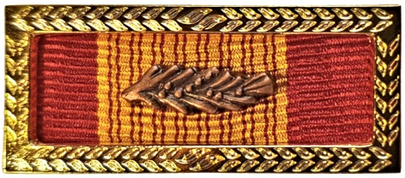 Current Issue

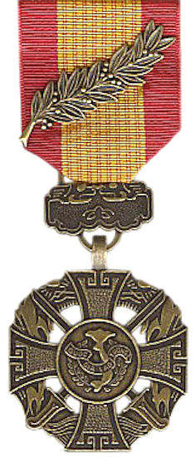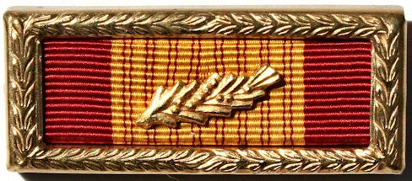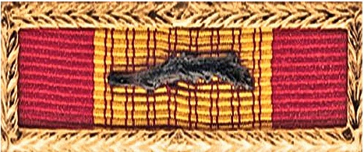

Medal with Palm Alternative designs

DH&A say that members may apply to exchange the gold version for the bronze. (but not compulsory!)

